Math 1 Name_________________________

**3-1 – 3-3 Review** Date________

The percentage of male and female teachers in Ohio starting in the year 1970 are approximated by the equations  below.

Percentage of male teachers: *m*(*t*)= 22 + 0.25*t*

Percentage of female teachers: *f*(*t*) = 78 - 0.25*t*

1. Write equations or inequalities that would help you answer the questions below. **Do not solve the equation or inequality.**

a. In 1986, what percent of teachers would be male? How many female?

b. When will the percent of female teachers fall to 60%?

c. When will half of the teachers be male?

2. Write questions about trends in percent of male and female teachers that can be answered by solving the following equations and inequalities:

a. 78 - 0.25*t* = 20

b. 78 - 0.25(24) = *f*(24)

c. *m*(90)= 22 + 0.25(90)

d. 56> 22 + 0.25*t*

e. 78 - 0.25*t* > 22 + 0.25*t*

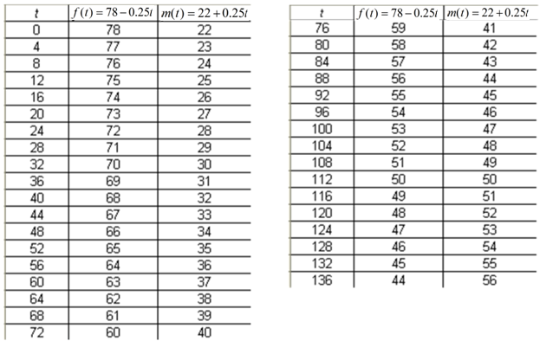

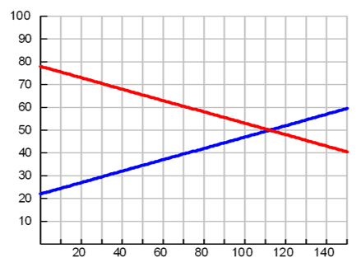

3. Use the table and graph to find the solutions to the equations and inequalities below then write a sentence explaining what each solution means.

a. 29 = 22 + 0.25*t*

b. 62 < 78 - 0.25*t*

c. *m*(116) = 22 + 0.25(116)

d. 78 - 0.25*t* = 22 + 0.25*t*

Solve the following systems by using substitution and elimination at least once each.

4.  5. 

6.  7. 

Solve the systems below by graphing.

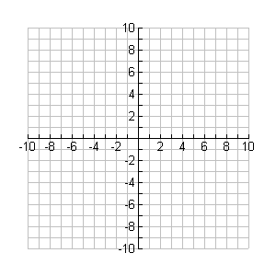8.  9. 

Solution: ___________________ Solution: ___________________